P.3 LITERACY 1B LESSON NOTES TERM III
WEEK:2 Lesson1&2
Spellings
- receive
- social
- transport
- service
- ethnic
GENDER AND CULTURE IN OUR SUB-COUNTY
Culture
1. What is culture?
Culture is the way people live and behave in a given society.
2. Aspects or components of culture
Culture includes the following;
- customs
- food
- taboos
- language
- religion/beliefs etc

Customs
3. What are customs?
Customs are traditional or religious practices in a society.
Customs are acceptable behaviour in a society.
4. Examples of customs/ cultural practices

- marriage
- naming children
- greeting
- dressing
- dancing
- burial
- tattooing
- twin celebration

- male circumcision e.g. among the Bagisu
- female circumcision e.g. among the Sabiny

Activity
Learners shall tell stories about cultural practices.
Exercise
- Define the term culture.
- Identify any three components of culture.
- What are customs?
- Which custom is common among all Bagisu?
- Mention any other two common customs in our society.

WEEK: 2 Lesson 3 &4
Spellings
- culture
- society
- custom
- circumcision
- traditional

MARRIAGE
1. What is marriage?
Marriage is when a man and a woman become husband and wife.
-Marriage is an agreement/union between a man and a woman as husband and wife.

2. Types of marriage
- Religious marriage
- Customary /Traditional marriage
- Civil marriage

3. Religious marriage
This takes place in the church, mosque or temple.
-It is done by a religious leader e.g Reverend, Imam, Pastor, Priest etc.
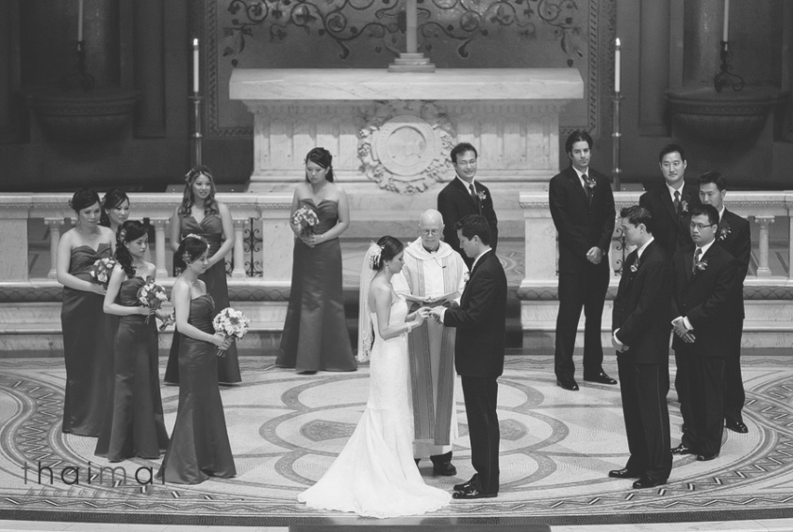
A religious marriage
Activity
Learners shall role play a religious marriage festival.
Exercise
- What is marriage?
- Name three types of marriage.
- Who officiates a religious marriage?
- Identify any one place where a religious marriage can take place.

WEEK: 2 Lesson 5&6
Spellings
- marriage
- religious
- union
- agreement
- reverend

1. Customary /Traditional marriage
Here the groom takes bride price to the girl’s parents before he is given the girl for marriage.
- It can also be called cultural marriage.
2. What is bride price?
Bride price is the money or items that the groom gives to the bride’s family before he is given the bride.
-It can also be called bride wealth/ dowry. 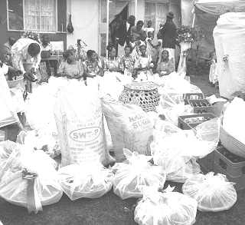
Some of the bride price items
3. Examples of bride price items given today

- cows
- goats
- cocks
- clothes
- sodas
- beers
- cars
- fruits
- chairs etc

Activity
Learners shall discuss some if the activities involved during introduction ceremony and the items taken.

Exercise
- King is to queen as groom is to___________.
- What do we call the items paid to the bride’s family by the groom?
- Draw, name and colour any four examples of such items.

WEEK: 2 Lesson 7
Spellings
- bride price
- dowry
- groom
- cultural
- customary

1. Civil marriage
This is the type of marriage that is done before a government official called the Chief Administrative Officer. (CAO)
-In Kampala where there is no CAO, it is officiated by the Registrar General.
-A marriage certificate is given in the presence of witnesses. 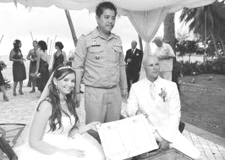
A civil marriage

2. Qualities of a good marriage partner
- Should be responsible.
- Should be respectful.
- Should be God-fearing.
- Should not be too old or too young.
- Should be loving.
- Should be healthy.
Activity
Learners shall discuss the factors or qualities one considers when selecting a wife/ husband for marriage.

Exercise
- Write CAO in full.
- State three qualities of a good marriage partner.

WEEK: 3 Lesson 1&2
Spellings
- civil
- chief
- administrative
- certificate
- witness

1. Problems facing marriages
- Divorce; Separation of married partners/couples.
- Quarrels
- Poverty
- Lack of food
- Child abuse
- Alcoholism
- Adultery; Sex outside marriage
- Diseases like AIDS
NB: The problems of marriage are the causes of divorce.

2. Effects of divorce to children
- Children may lack basic needs.
- Children may be abused by step parents.
- Children may lack parental love.
Activity
Learners shall discuss the reasons why some parents separate.

Exercise
- Give any three problems facing marriages/ families today.
- State two ways how any of the above problems can be controlled.
- How does divorce affect children?

WEEK: 3 Lessons 3& 4
Spellings
- divorce
- couples
- poverty
- adultery
- alcoholism

GREETING
1. In most tribes, boys/men greet while standing upright while girls/women kneel down.
-This is done as a sign of respect.
2. Why we greet
- To show respect.
- To build relationship.
- To create unity.
DRESSING
3. Tribes have different cultural wears.
4. A table showing tribes and their traditional wear
Tribe(s) | Cultural wear
Baganda and Basoga | Men-Kanzu  Women-Gomesi/Busuuti
Banyankole,Batooro,Banyoro | Men-Kanzu  Women-Mushanana/sash
Karimojong | Beads and animal skins

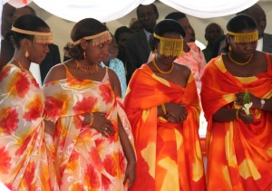 | 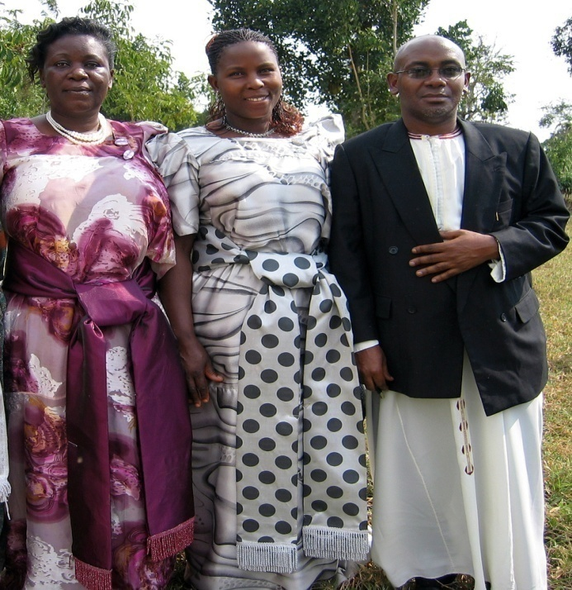
Ankole ladies in Mushanana | Baganda ladies in Gomesi & a man in Kanzu

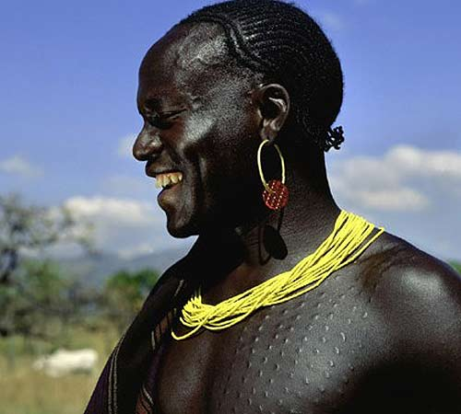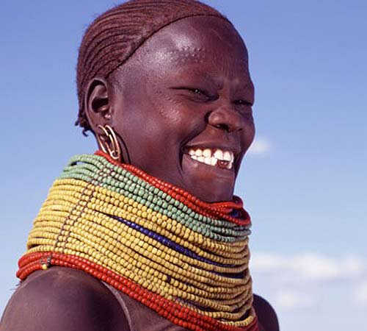
A Karimojong man with beads A Karimojong woman with beads
- Examples of modern clothes

- dresses
- skirts
- shirts and blouses
- vests
- trousers
- jackets/ coats etc

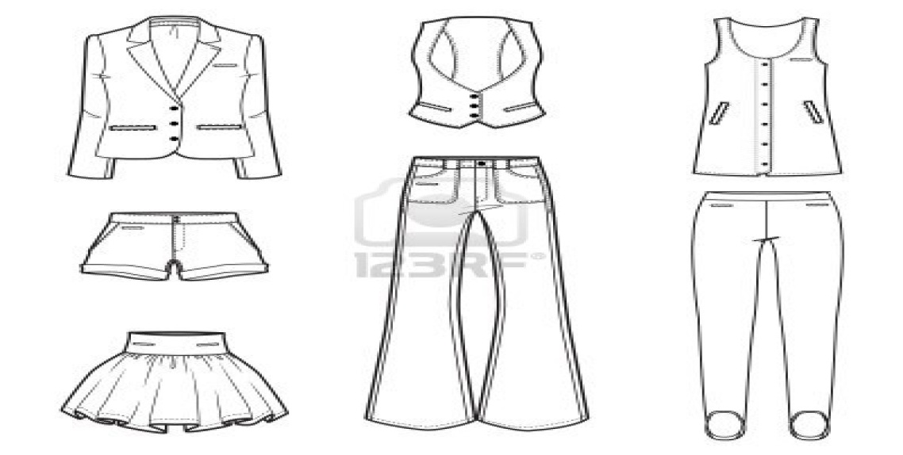

5. Why people wear clothes.
- For easy identification.
- To be smart.
- For privacy.
- To promote their culture.

Activity
Learners shall demonstrate how they greet in their tribes/ cultures and observe some traditional clothes.
Exercise
- Why do we greet people?
- Identify the traditional wear for these tribes.
- Baganda
- Karimojongs
- Banyankole
3. Why do people wear clothes?
WEEK:3 Lesson 5 &6
Spellings
- greet
- identification
- respect
- kneel
- relationship

CHILD NAMING
1. Children are named differently according to tribes, religions and clans.
2. Long ago and today, newly born babies are given names by their parents, paternal grand fathers or clan heads.
3. The names given are of their fallen dear ones, physical features, seasons of the year etc.
4. Different names carry different meanings e.g.
Name | Meaning | Tribe
Kasozi | Hill | Baganda  ‘’  ‘’  ‘’  ‘’
Lutalo | War | Baganda  ‘’  ‘’  ‘’  ‘’
Kiwanuka | Thunder | Baganda  ‘’  ‘’  ‘’  ‘’
Walumbe | Death | Baganda  ‘’  ‘’  ‘’  ‘’
Musisi | Earthquake | Baganda  ‘’  ‘’  ‘’  ‘’
Rukundo | Love | Banyankole  ‘’
Kamusiime | Praise Him | Banyankole  ‘’
Nabwire | Night (for girls) | Samia  ‘’
Wabwire | Night (for boys) | Samia  ‘’
Wanzala | Famine | Samia /Bagisu

5. Why children are given names.
- For identification.
- To promote culture.
Activity
Learners identify their surnames and their meanings.
Exercise
- What do you call the father of your father?
- Give one reason why children are given names.
- What do these Baganda names mean?
- Walumbe
- Musisi
- Kasozi

WEEK:3 Lesson 7&1
Spellings
- religion
- paternal
- thunder
- famine
- earthquake

Naming twins
In different tribes, twins and their parents are given special names e.g.
Names of twins | Sex | Tribe
Babirye | Female (old) | Baganda
Nakato | “ (young) | Baganda
Wasswa | Male (o) | Baganda
Kato | “ (y) | Baganda
Babirye | Female (o) | Basoga
Kawudha | “ (y) | Basoga
Waiswa | Male (o) | Basoga
Tenywa | “ (y) | Basoga
Isingoma | Male (o) | Banyankole, Batooro, Banyoro, Bakiga
Kato | “ (y) | Banyankole, Batooro, Banyoro, Bakiga
Nyangoma | Female (0) | Banyankole, Batooro, Banyoro, Bakiga
Nyakato | “ (y) | Banyankole, Batooro, Banyoro, Bakiga
Names of Parents
Isabirye | Father of twins | Basoga
Nabirye | Mother of twins | Basoga
Isabalongo | Father of twins | Banyankole, Batooro, Banyoro, Bakiga
Nyinabalongo | Mother of twins | Banyankole, Batooro, Banyoro, Bakiga
Salongo | Father of twins | Baganda
Nalongo | Mother of twins | Baganda

Activity
Learners shall;
-Identify the names of twins at home, in their class/school.
-Find out from their parents/ guardians the twins names in their tribes.
Exercise
- What do we call two children born at the same time by the same mother?
- Write two twin names for boys in Baganda tribe.
- Who is the twin father and mother among the Banyankole?
- Father
- Mother

WEEK:4 Lesson 2 &3
Spellings
- twins
- special
- male
- female
- young
FOOD
1. What is food?
Food is anything we eat or drink and is useful in the body.
2. What is a staple food?
This is a type of food eaten by most people in an area, tribe or region.
3. Tribes have different food dishes or staple foods.
4. A table showing tribes and their traditional dishes/staple foods.
Tribe | Food dish
Baganda | Matooke
Banyankole | Millet(kalo) mixed with cassava flour, matooke
Samia | Millet mixed with cassava flour
Basoga | Sweet potatoes and posho
Iteso | Millet mixed with cassava flour
Acholi | Millet /sorghum mixed with cassava flour

Activity
Learners shall find out the staple foods of their tribes and demonstrates how they are prepared.
Exercise
- Define the term staple food.
- What is the staple food for the following tribes?
- Basoga
- Banyankole
- Baganda
- Identify one tribe whose traditional food is millet?

WEEK:4 Lesson 4 &5
Spellings
- staple food
- traditional
- dishes
- flour
- sorghum

FOOD TABOOS
1. What is a food taboo?
This is a forbidden food in a given society.
-A food taboo is a type of food that a person of a given tribe, religion or clan is not allowed to eat.
2. Examples of food taboos
- Moslems do not eat pork.
- Clans do not eat their totems.
- Hindus do not eat meat.
- The Seventh day Adventists do not eat pork.
3. A taboo is anything forbidden is a given society.
4. Importance of customs in a society
- They attract tourists.
- They promote culture.
- They promote morals in society.
- They are for study purposes.
- They spell out the gender roles.
- Customs promote unity/co-operation.

Activity
Learners shall;
-Identify their clan totems.
- Discuss some of the common taboos in their society.
Exercise
- What does the word food taboo mean?
- Identify any two common food taboos.
- What is your totem?
- State two ways how customs can be useful to us.

WEEK:4 Lesson 6
Spellings
- taboo
- society
- forbidden
- totem
- morals

CLANS
1. What is a clan?
A clan is a group of people under the same forefather or ancestor.
2. Symbols of a clan
- Name
- Drum sound
- Totem
- Forefather/ancestor

3. Duties of a clan head
i) Settles disputes/ conflicts among clan members.
ii) Registers clan members and the newly born babies.
iii) Keeps clan records.
iv) Organizes clan meetings.

Activity
Learners shall identify the names of their clans and some of the practices they perform.
Exercise
- What is a clan?
- Name any two symbols of a clan.
- Give two roles of a clan head.

WEEK:4 Lesson 7&1
Spellings
- clan head
- fore-father
- symbols
- ancestor
- disputes

Forms of clans in Buganda
1. Clans are grouped into;
- Animal form
- Bird form
- Insect form
- Plant form
- Others
2. Examples in each form

- Animal form

- Mpologoma(lion)
- Ngo(leopard)
- Ngabi(antelope)
- Nkima(monkey)
- Nte(cow)
- Mbwa(dog)
- Ndiga (sheep)
- Njovu(elephant

b) Bird form
- Nyange(egret)
- Nakisige
- Namungoona (raven/crow)
- Ngaali (crested crane) etc
c) Plant form
- Kobe
- Butiko(mushroom)
d) Insect form
- Nsenene (grasshopper)
- Kinyomo(sugar ant)
e) Others
- Nkebuka
- Mutima(heart)
- Amazzi g’ekisasi
- Lukato etc

Activity
Learners shall identify the totems of the different Baganda clans.
Exercise
- Name any two animal forms of clans in Buganda.
- Identify any other two examples of clans in Buganda.
- Which is the ruling clan in Buganda?
- What title is given to the king of Buganda?
- Who is current king of Buganda?
- Write the name of your clan.
WEEK:6 Lesson 2&3
Spellings
- Buganda
- Bunyoro
- crested crane
- crow
- egret

Ways of promoting/preserving culture
- Through music, dance and drama.
- Writing in books.
- Attending clan meetings.
- Attending funerals and other cultural festivals.
- Visiting elders.
- Planting medicinal plants like molinga, mulondo, bombo, mululuza.
- Through succession.
- Installing and enthroning cultural leaders like kings.

Activity
Learners shall sing and listen to some traditional songs that promote culture.
Exercise
- State any four ways of preserving our culture.
- Why do people attend burial ceremonies?
- Identify any one role of cultural leaders.
- Why should children be taught their cultures?

WEEK:6 Lesson 4&5
Spellings
- preserve
- funeral
- festival
- norms
- medicinal

1. Importance of cultural practices
- They teach good morals.
- They help us to preserve culture.
- They teach people more about their tribes.
- For cultural identity.
- They attract tourists.
2. Dangers of cultural practices
- Traditional circumcision can spread diseases like HIV/AIDS.
- Some names given have bad effects/impacts on the children e.g. ‘Ndikulwange’ meaning ‘being lonely’.
- Some obscene words and songs are used during naming of twins.
- Open circumcision causes public shame.
- Forbidding people from eating some foods leads to malnutrition.
- FGM is against human rights.

NB: FGM in full is Female Genital Mutilation
-It can also be called female circumcision.
-It is common among the Sabiny in Kapchorwa district.

Activity
Learners shall;
-Identify some of the dangerous cultural practices and explain their dangers.
- Listen and tell stories about dangerous cultural practices.
Exercise
- Identify any one danger of food taboos to people.
- Which tribes in Uganda carry out these types of circumcision?
a. Male circumcision
b. Female circumcision
- Why is male circumcision useful?
- How can culture be dangerous to people?
WEEK:6 Lesson 6&7
Spellings
- identity
- allergic
- practice
- malnutrition
- obscene
GENDER
- What is gender?
Gender is the state of being male or female and their roles.
-Sex is the state of being male or female.
2. Types of gender
There are two types of gender namely;
- Masculine gender
- Feminine gender
- 3. Traditional gender roles
-In the traditional society males and females played different roles.
a) For men /boys
- Fishing and hunting
- Looking after cattle.
- Protecting the family.
- Building the house.

b) For Females/girls
- Cleaning the home.
- Taking care of the children and the husband.
- Cooking food for the family members.

Activity
Learners shall role play the traditional gender roles for boys and girls.
Exercise
- What is the difference between gender and sex?
- Identify the two types of gender.
- Which roles were played by these people in the traditional society?
- men
- women
WEEK:7 Lesson 1&2
Spellings
- gender
- masculine
- feminine
- traditional
- male
Gender roles in our modern society
1. In our modern society both men/boys and women/girls can share work/roles.

2. Activities done by both girls and boys

- Fetching water
- Hunting and fishing
- Sweeping the compound
- Going for shopping
- Washing clothes
- Cooking food
- Driving
- Fetching firewood
- Mopping the house
- Milking the cows
- Taking care of the baby
- Fetching firewood

Activity
Learners shall discuss and role play the activities that both girls and boys can do at home and at school.
Exercise
- Identify any two activities that both girls and boys can do at home.
- How were girls treated differently from boys in society?

WEEK: 7 Lesson 3&4
Spellings
- roles
- modern
- cattle
- building
- husband

Gender equity
1. What is gender equity?
This is the treating of both boys and girls fairly/equally.
-Gender inequality is the treating of boy and girls unfairly.
2. Work must between boys and girls must be divided equally.
3. Boys and girls must be given equal rights
4. Ways of promoting gender equity
- Fair distribution of work.
- Providing needs to both boys and girls.
- Giving fair punishments to both boys and girls
- Giving equal opportunities to both boys and girls
- Allowing both boys and girls to express their feelings freely.
- By educating both the girl and the boy child.

5. What shows that girls and boys are equal?
- Both boys and girls can excel in studies.
- Both boys and girls are equally bright.
- Girls can do jobs that boys do.
- Both are human beings.
- Both can do all games and sports.
- Both have emotions.

Activity
Learners shall;
-Role play the shared roles
-Discuss the unfair ways boys and girls are treated in homes.
Exercise
- What is gender equity?
- State two ways of promoting gender equity in a home.
- Why girls and boys should be treated equally?

WEEK:7 Lesson 5
Tropical test
- What is culture?
- Name any two dangerous cultural practices.
- Give any two importance of culture.
- What is gender equity?
- How is can we promote gender equity at school
- Identify any one food taboo
- State any two ways we can preserve our African culture.
- What do we call the acceptable behavior in a society?
- Mention any two activities that can be done by both boys and girls.
- What is marriage?
- Why do people marry?
- Give any two effects of divorce to the children.
- How are customs important to us?

WEEK: 7 Lesson 6
Spellings
- equity
- equally
- promote
- opportunity
- misunderstanding

THEME: BASIC TECHNOLOGY IN OUR SUB-COUNTY/DIVISION
1. What is technology?
Technology is the use of machines to do work.
It is also the use of scientific knowledge to make thing.
2. Types of technology
- Traditional technology
- Modern or advanced technology

a. Traditional technology
This is where local methods and hands to are used to make things.
-Some of the things made and used are; hoes, arrows, brooms, mats etc.
b. Modern technology
This is where advanced tools like computers, phones, cars and tractors are made and used.

Activity
Learners shall identify some of the things made and used in the modern world.
Exercise
- What term is used to mean the use of machines to simplify work?
- Draw name and colour two things used in this modern technology.
- Which type of technology was used by people of long ago?

WEEK: 7 Lesson 7&1
Spellings
- technology
- scientific
- knowledge
- machines
- equipment

Natural and artificial materials in our sub-county
1. Things in our environment are made from natural and artificial materials
2. Natural materials
These are materials got from nature.
3. Examples of natural materials;

- Banana fibres
- Palm leaves
- Clay
- Sisal
- Minerals
- Papyrus
- Wood
- Grass
- Hides and skills

NB: Discuss the characteristics of the natural materials used in terms of colour, texture, shape, weight, size etc.
4. Sources of natural materials
Materials | Source
banana fibres | banana plantations
sisal and fruits | plantations
clay, papyrus and palm leaves | swamps
minerals | mines
hides and skins | animals
Sticks and grass | bushes

Activity
Learners shall observe and identify the natural materials and where they are got from.
Exercise
- Identify any three natural materials in our environment.
- Where are these materials got?
- Sisal
- Minerals
- Name any two raw materials got from swamps.
WEEK: 8Lesson 2&3
Spellings
- natural
- materials
- environment
- plantation
- papyrus

1. Processing and making things from natural materials
The table below shows things made from natural materials.
Material | Things made/products
clay | pots, cups, plates, stoves etc
palm leaves and banana fibres | mats, dolls, bags, hats
wood | stools, tables, chairs, sculptures, pestles, mortar
sisal | ropes, carpets, door mats, bags
grass | brooms
iron | arrows, spears , hooks ,hoes
beads | necklaces, rosaries
fruits | Juice and salads
Sticks | stools, tables, chairs etc

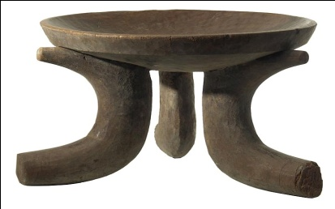 | 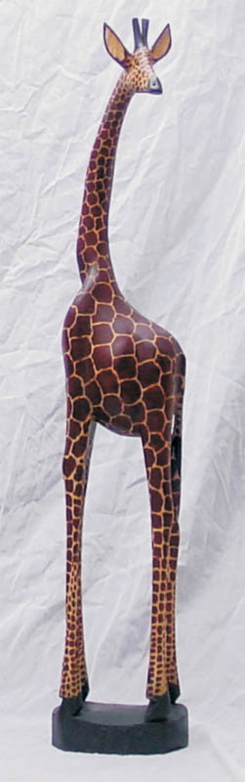 | 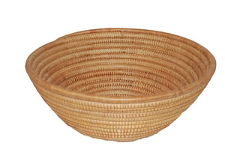
stool |  | basket
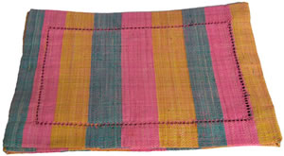 |  | 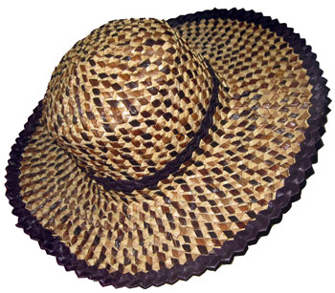
doormat | sculpture of a giraffe | hat

NB: Conduct a practical lesson about making juice and salads from fruits.
2. Who is a blacksmith?
Is a person who makes things out of iron.
3. Things made by a blacksmith;

- spears
- hoes
- arrows
- hooks
- stoves
- pans

Activity
Learners shall;
-Sort out metallic from non-metallic materials.
- Identify, observe, draw and colour the things made from natural materials.

Exercise
- Which raw materials are used for making these items?
- ropes
- necklaces
- mats
- arrows
- Who is a potter?
- Draw, name and colour any three items made by a potter.

WEEK:8 Lesson 4&5
Spellings
- iron
- blacksmith
- banana fibres
- palm leaves
- necklace

1. Artificial materials
These are materials that can be re-cycled to make other things.
2. Examples of artificial materials

- wires
- plastics
- straws
- scrap metals
- paper
- polythene bags
- synthetic rubber
- bottle tops

3. Processing and making things from artificial materials.
The table below shows things made from natural materials.
Material | Products
plastics | mugs, plates, doll, toys
wires | toys, hooks, traps
straws | mats, bags, decorations, hats
polythene bags | balls, dolls, bags
paper | bags, envelopes, decoration etc
scrap metal | nails, garden tools like hoes
bottle tops | toys, abacuses and shakers

4. Importance of things made from natural and artificial materials
- Toys and dolls are used as play kits.
- Some are used for decoration.
- People sell them to get money.
- Some are worn as ornaments.
- They are for study purpose.
- They attract tourists.

Activity
Learners shall;
-Observe and name the things made from natural material.
- Discuss the importance of the things made from natural and artificial materials.
Exercise
1. Which artificial raw materials are used for making these items?
- balls
- envelopes
- mugs
2. State any two uses of crafts to people.
WEEK: 8 Lesson6&7
Spellings
- artificial
- plastic
- polythene
- scrap
- decoration

CRAFTS
1. What are crafts?
These are things made from local materials using our hands.
2. Examples of crafts

- dolls
- mats
- ropes
- vases
- stoves
- stools
- carpets

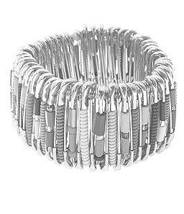 |  | 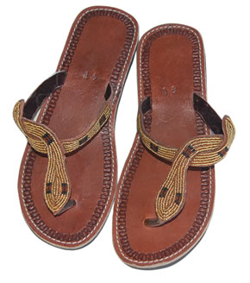
bracelet | hat | sandals
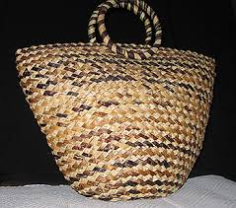 | 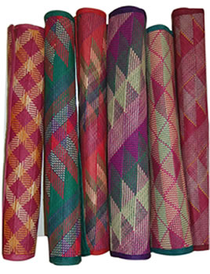 | 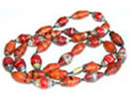
bag | mats | necklace

3. Importance of technology
How is technology useful to us?
- It makes work easy.
- It makes life better.
- It increases production of goods.
- It is a source of income.
Activity
Learners shall;
-Observe, draw, name and colour some crafts.
-Demonstrate how to make different crafts.
Exercise
- How has technology helped us?
- A potter is to clay as a _________is to iron.
- Define the term crafts.
- Draw, name and colour any two crafts.
WEEK: 9 Lesson 1
Topical test
- Define the term technology?
- Name any one type of technology.
- Identify the local materials that can be used for making these items
- ropes
- pots
- necklaces
- What are crafts?
- How useful is the crafts industry to us?
- Who is a black smith?
- Draw and name any two products made by a blacksmith.
- Which type of technology does a rural potter use?
- How useful is technology in our daily life?

